**08/14/14**

**Adding missing Epson data for subject 2, 4, 6, and also after cleaning the data.**

**With All subjects**

|  |  |  |  |  |  |  |  |  |
| --- | --- | --- | --- | --- | --- | --- | --- | --- |
| **Tests of Between-Subjects Effects** | | | | | | | | |
| Dependent Variable: TotalTime | | | | | | | | |
| Source | Type III Sum of Squares | df | Mean Square | F | Sig. | Partial Eta Squared | Noncent. Parameter | Observed Powerb |
| Corrected Model | 46958.335a | 127 | 369.751 | 3.041 | .000 | .379 | 386.218 | 1.000 |
| Intercept | 77673.636 | 1 | 77673.636 | 638.841 | .000 | .503 | 638.841 | 1.000 |
| **Experiment_Condition** | **558.262** | **3** | **186.087** | **1.531** | **.205** | **.007** | **4.592** | **.405** |
| Task | 5513.338 | 7 | 787.620 | 6.478 | .000 | .067 | 45.345 | 1.000 |
| Action_Code | 11804.253 | 3 | 3934.751 | 32.362 | .000 | .133 | 97.086 | 1.000 |
| Experiment_Condition * Task | 3473.401 | 21 | 165.400 | 1.360 | .130 | .043 | 28.568 | .916 |
| Experiment_Condition * Action_Code | 1337.059 | 9 | 148.562 | 1.222 | .278 | .017 | 10.997 | .607 |
| Task * Action_Code | 17711.781 | 21 | 843.418 | 6.937 | .000 | .187 | 145.674 | 1.000 |
| Experiment_Condition * Task * Action_Code | 10706.635 | 63 | 169.947 | 1.398 | .027 | .122 | 88.059 | 1.000 |
| Error | 76841.847 | 632 | 121.585 |  |  |  |  |  |
| Total | 240511.037 | 760 |  |  |  |  |  |  |
| Corrected Total | 123800.182 | 759 |  |  |  |  |  |  |
| a. R Squared = .379 (Adjusted R Squared = .255) | | | | | | | | |
| b. Computed using alpha = .05 | | | | | | | | |

**Adding missing Epson data for subject 2, 4, 6, and also after cleaning the data.**

**Excluding subject 3**

|  |  |  |  |  |  |  |  |  |
| --- | --- | --- | --- | --- | --- | --- | --- | --- |
| **Tests of Between-Subjects Effects** | | | | | | | | |
| Dependent Variable: TotalTime_11Sub_N3 | | | | | | | | |
| Source | Type III Sum of Squares | df | Mean Square | F | Sig. | Partial Eta Squared | Noncent. Parameter | Observed Powerb |
| Corrected Model | 51074.704a | 127 | 402.163 | 3.873 | .000 | .458 | 491.884 | 1.000 |
| Intercept | 70036.434 | 1 | 70036.434 | 674.499 | .000 | .537 | 674.499 | 1.000 |
| Experiment_Condition | 1060.424 | 3 | 353.475 | 3.404 | .017 | .017 | 10.213 | .768 |
| Task | 6441.411 | 7 | 920.202 | 8.862 | .000 | .096 | 62.035 | 1.000 |
| Action_Code | 11880.861 | 3 | 3960.287 | 38.140 | .000 | .164 | 114.421 | 1.000 |
| Experiment_Condition * Task | 5074.364 | 21 | 241.636 | 2.327 | .001 | .077 | 48.870 | .997 |
| Experiment_Condition * Action_Code | 2623.772 | 9 | 291.530 | 2.808 | .003 | .042 | 25.269 | .961 |
| Task * Action_Code | 18243.783 | 21 | 868.752 | 8.367 | .000 | .232 | 175.700 | 1.000 |
| Experiment_Condition * Task * Action_Code | 16150.285 | 63 | 256.354 | 2.469 | .000 | .211 | 155.538 | 1.000 |
| Error | 60431.841 | 582 | 103.835 |  |  |  |  |  |
| Total | 219224.032 | 710 |  |  |  |  |  |  |
| Corrected Total | 111506.546 | 709 |  |  |  |  |  |  |
| a. R Squared = .458 (Adjusted R Squared = .340) | | | | | | | | |
| b. Computed using alpha = .05 | | | | | | | | |

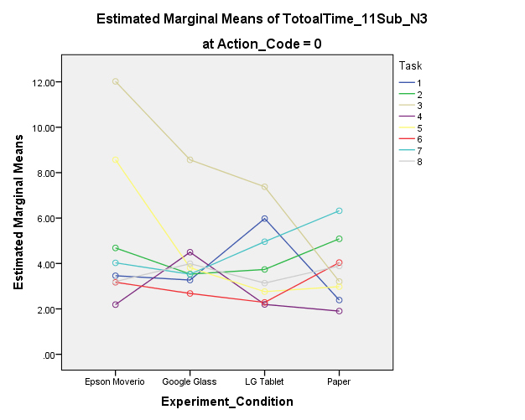 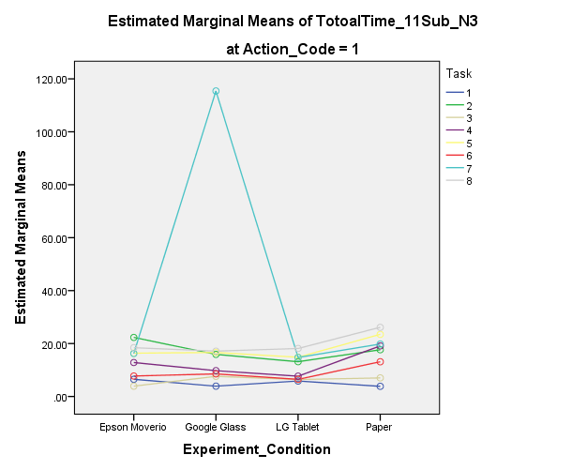

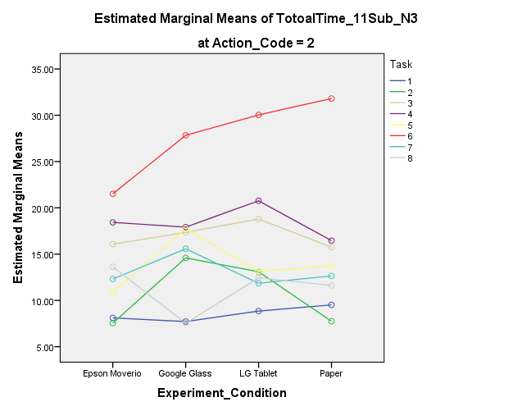 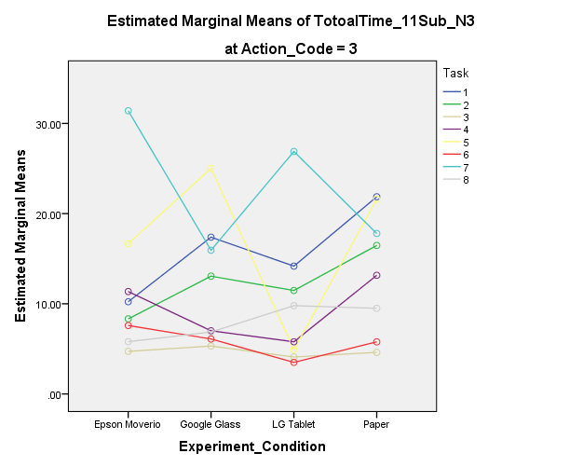

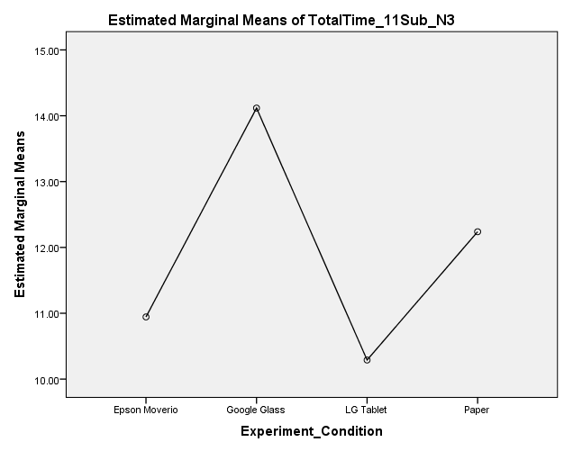

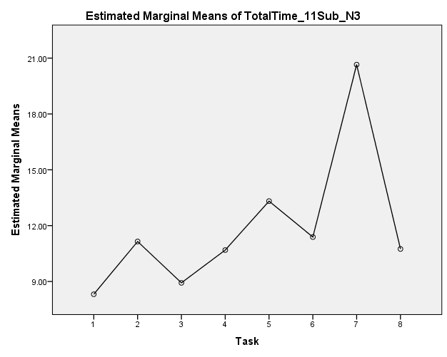

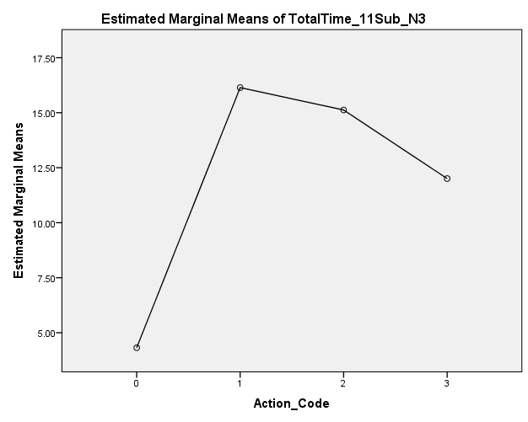

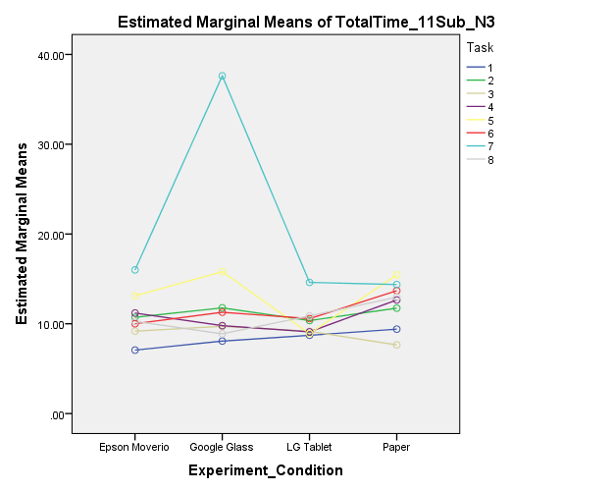

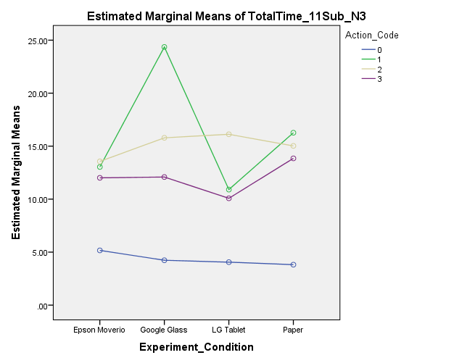

Means

|  |  |  |  |  |  |  |
| --- | --- | --- | --- | --- | --- | --- |
| **8. Experiment_Condition * Task * Action_Code** | | | | | | |
| Dependent Variable: TotalTime_11Sub_N3 | | | | | | |
| Experiment_Condition | Task | Action_Code | Mean | Std. Error | 95% Confidence Interval | |
| Lower Bound | Upper Bound |
| Epson Moverio | 1 | 0 | 3.460 | 5.095 | -6.547 | 13.467 |
| 1 | 6.485 | 7.205 | -7.667 | 20.637 |
| 2 | 8.114 | 3.222 | 1.785 | 14.443 |
| 3 | 10.225 | 7.205 | -3.927 | 24.377 |
| 2 | 0 | 4.685 | 7.205 | -9.467 | 18.837 |
| 1 | 22.320 | 5.095 | 12.313 | 32.327 |
| 2 | 7.553 | 3.222 | 1.224 | 13.882 |
| 3 | 8.325 | 7.205 | -5.827 | 22.477 |
| 3 | 0 | 12.020 | 5.095 | 2.013 | 22.027 |
| 1 | 3.900 | 5.883 | -7.655 | 15.455 |
| 2 | 16.074 | 2.942 | 10.297 | 21.852 |
| 3 | 4.720 | 5.883 | -6.835 | 16.275 |
| 4 | 0 | 2.187 | 5.095 | -7.819 | 12.194 |
| 1 | 12.817 | 5.883 | 1.262 | 24.371 |
| 2 | 18.427 | 2.631 | 13.259 | 23.594 |
| 3 | 11.360 | 5.883 | -.195 | 22.915 |
| 5 | 0 | 8.568 | 4.160 | .398 | 16.739 |
| 1 | 16.348 | 4.160 | 8.178 | 24.519 |
| 2 | 10.858 | 4.160 | 2.688 | 19.029 |
| 3 | 16.663 | 5.883 | 5.109 | 28.218 |
| 6 | 0 | 3.173 | 5.883 | -8.381 | 14.728 |
| 1 | 7.745 | 4.160 | -.425 | 15.915 |
| 2 | 21.520 | 4.160 | 13.350 | 29.690 |
| 3 | 7.593 | 5.883 | -3.961 | 19.148 |
| 7 | 0 | 4.028 | 4.557 | -4.922 | 12.978 |
| 1 | 16.247 | 5.883 | 4.692 | 27.801 |
| 2 | 12.316 | 2.631 | 7.149 | 17.483 |
| 3 | 31.410 | 5.883 | 19.855 | 42.965 |
| 8 | 0 | 3.202 | 5.095 | -6.804 | 13.209 |
| 1 | 18.438 | 4.160 | 10.267 | 26.608 |
| 2 | 13.627 | 2.942 | 7.850 | 19.405 |
| 3 | 5.796 | 5.883 | -5.759 | 17.351 |
| Google Glass | 1 | 0 | 3.270 | 4.160 | -4.900 | 11.440 |
| 1 | 3.900 | 5.883 | -7.655 | 15.455 |
| 2 | 7.720 | 2.631 | 2.553 | 12.887 |
| 3 | 17.390 | 5.883 | 5.835 | 28.945 |
| 2 | 0 | 3.533 | 5.883 | -8.021 | 15.088 |
| 1 | 15.897 | 4.160 | 7.726 | 24.067 |
| 2 | 14.596 | 2.631 | 9.429 | 19.763 |
| 3 | 13.063 | 5.883 | 1.509 | 24.618 |
| 3 | 0 | 8.565 | 4.160 | .395 | 16.735 |
| 1 | 7.627 | 5.883 | -3.928 | 19.181 |
| 2 | 17.354 | 2.942 | 11.577 | 23.132 |
| 3 | 5.317 | 5.883 | -6.238 | 16.871 |
| 4 | 0 | 4.497 | 5.883 | -7.058 | 16.051 |
| 1 | 9.757 | 5.883 | -1.798 | 21.311 |
| 2 | 17.917 | 2.631 | 12.749 | 23.084 |
| 3 | 7.003 | 5.883 | -4.551 | 18.558 |
| 5 | 0 | 3.815 | 4.160 | -4.355 | 11.985 |
| 1 | 16.623 | 4.160 | 8.453 | 24.794 |
| 2 | 17.752 | 4.160 | 9.581 | 25.922 |
| 3 | 25.020 | 5.883 | 13.465 | 36.575 |
| 6 | 0 | 2.680 | 5.883 | -8.875 | 14.235 |
| 1 | 8.527 | 4.160 | .356 | 16.697 |
| 2 | 27.833 | 4.160 | 19.663 | 36.004 |
| 3 | 6.097 | 5.883 | -5.458 | 17.651 |
| 7 | 0 | 3.528 | 5.095 | -6.479 | 13.534 |
| 1 | 115.410 | 7.205 | 101.258 | 129.562 |
| 2 | 15.578 | 3.222 | 9.249 | 21.907 |
| 3 | 15.940 | 7.205 | 1.788 | 30.092 |
| 8 | 0 | 3.990 | 5.883 | -7.565 | 15.545 |
| 1 | 17.132 | 5.095 | 7.126 | 27.139 |
| 2 | 7.539 | 3.603 | .463 | 14.615 |
| 3 | 6.870 | 7.205 | -7.282 | 21.022 |
| LG Tablet | 1 | 0 | 5.978 | 4.160 | -2.192 | 14.149 |
| 1 | 5.857 | 5.883 | -5.698 | 17.411 |
| 2 | 8.849 | 2.631 | 3.682 | 14.017 |
| 3 | 14.177 | 5.883 | 2.622 | 25.731 |
| 2 | 0 | 3.737 | 5.883 | -7.818 | 15.291 |
| 1 | 13.137 | 4.160 | 4.966 | 21.307 |
| 2 | 13.095 | 2.631 | 7.928 | 18.263 |
| 3 | 11.473 | 5.883 | -.081 | 23.028 |
| 3 | 0 | 7.378 | 4.160 | -.792 | 15.549 |
| 1 | 6.400 | 5.883 | -5.155 | 17.955 |
| 2 | 18.788 | 2.942 | 13.011 | 24.566 |
| 3 | 4.097 | 5.883 | -7.458 | 15.651 |
| 4 | 0 | 2.197 | 5.883 | -9.358 | 13.751 |
| 1 | 7.670 | 5.883 | -3.885 | 19.225 |
| 2 | 20.761 | 2.631 | 15.594 | 25.929 |
| 3 | 5.783 | 5.883 | -5.771 | 17.338 |
| 5 | 0 | 2.760 | 5.095 | -7.247 | 12.767 |
| 1 | 14.822 | 5.095 | 4.816 | 24.829 |
| 2 | 13.133 | 5.095 | 3.126 | 23.139 |
| 3 | 4.920 | 7.205 | -9.232 | 19.072 |
| 6 | 0 | 2.285 | 7.205 | -11.867 | 16.437 |
| 1 | 6.482 | 5.095 | -3.524 | 16.489 |
| 2 | 30.037 | 5.095 | 20.031 | 40.044 |
| 3 | 3.500 | 7.205 | -10.652 | 17.652 |
| 7 | 0 | 4.960 | 4.160 | -3.210 | 13.130 |
| 1 | 14.737 | 5.883 | 3.182 | 26.291 |
| 2 | 11.858 | 2.631 | 6.691 | 17.025 |
| 3 | 26.890 | 5.883 | 15.335 | 38.445 |
| 8 | 0 | 3.137 | 5.883 | -8.418 | 14.691 |
| 1 | 18.133 | 4.160 | 9.963 | 26.304 |
| 2 | 12.443 | 3.072 | 6.408 | 18.477 |
| 3 | 9.793 | 5.883 | -1.761 | 21.348 |
| Paper | 1 | 0 | 2.388 | 4.160 | -5.782 | 10.559 |
| 1 | 3.830 | 5.883 | -7.725 | 15.385 |
| 2 | 9.518 | 2.631 | 4.351 | 14.685 |
| 3 | 21.870 | 5.883 | 10.315 | 33.425 |
| 2 | 0 | 5.087 | 4.160 | -3.084 | 13.257 |
| 1 | 17.653 | 4.160 | 9.483 | 25.824 |
| 2 | 7.747 | 2.631 | 2.580 | 12.915 |
| 3 | 16.470 | 5.883 | 4.915 | 28.025 |
| 3 | 0 | 3.207 | 5.883 | -8.348 | 14.761 |
| 1 | 7.010 | 10.190 | -13.004 | 27.024 |
| 2 | 15.758 | 3.603 | 8.682 | 22.833 |
| 3 | 4.615 | 7.205 | -9.537 | 18.767 |
| 4 | 0 | 1.902 | 5.095 | -8.104 | 11.909 |
| 1 | 19.105 | 7.205 | 4.953 | 33.257 |
| 2 | 16.459 | 3.222 | 10.130 | 22.788 |
| 3 | 13.160 | 7.205 | -.992 | 27.312 |
| 5 | 0 | 2.978 | 4.160 | -5.192 | 11.149 |
| 1 | 23.470 | 4.160 | 15.300 | 31.640 |
| 2 | 13.745 | 4.160 | 5.575 | 21.915 |
| 3 | 21.590 | 5.883 | 10.035 | 33.145 |
| 6 | 0 | 4.040 | 4.160 | -4.130 | 12.210 |
| 1 | 13.115 | 4.160 | 4.945 | 21.285 |
| 2 | 31.807 | 4.160 | 23.636 | 39.977 |
| 3 | 5.777 | 5.883 | -5.778 | 17.331 |
| 7 | 0 | 6.322 | 4.160 | -1.849 | 14.492 |
| 1 | 19.823 | 5.883 | 8.269 | 31.378 |
| 2 | 13.546 | 2.723 | 8.198 | 18.895 |
| 3 | 17.797 | 5.883 | 6.242 | 29.351 |
| 8 | 0 | 4.618 | 4.557 | -4.332 | 13.568 |
| 1 | 26.115 | 4.160 | 17.945 | 34.285 |
| 2 | 11.617 | 2.942 | 5.840 | 17.395 |
| 3 | 9.497 | 5.883 | -2.058 | 21.051 |